INDIA NON JUDICIAL

Government of Karnataka 

e-Stamp

Certificate No.IN-KA76860608623217U

Certificate Issued Date15-Jul-2022 05:43 PM

Account Reference

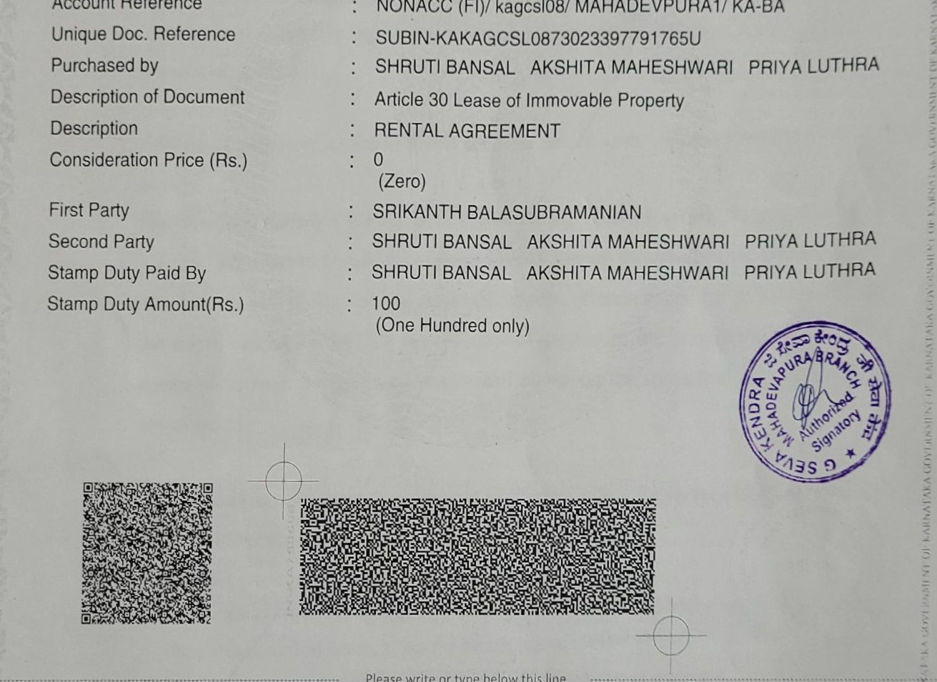

NONACC

(Fl)/

kagcs108/

MAHADEVPURAI/

KA-BA

Please

write

or

type

below

this

line

Unique Doc. Reference

Purchased by

Description of Document

RENTAL AGREEMENT

This Rental agreement entered into with mutual consent on the 15th Day Of July 2022 (15- 07-2022) between Mr. SRIKANTH BALASUBRAMANIAN, aged 47 years, S/o Mr. V.S. Balasubramanian, represented by his Geperal Power of Attorney Mr. V.S.Balasubramanian residing at Flat B102, Bhairavi Drupad Apartment, Next to Post Office , New Tippasandra, Bangalore — 560075 (Hereinafter called 'OWNER') of the one part and

Statutory Alert:

1, The authenticity of this Stamp ceHificate should be verified at 'wwwshciiostamp.com• or using e,Stamp Mobile App Ot Stock Holding. Any discrepancy in the details on th1S Certificate and as available on website J' Mobile App tenders it invalid

1. Ine onus ot checking the legitimacy on the users o' the certificate.
2. In case of any disaepancy please inform the Compelent Authouty.
3. Ms. SHRUTI BANSAL, aged 23 years, D/O. Mr. Atul Bansal and whose Permanent address at the time of this agreement is House no: 28-E, New Kitchlu Nagar, Ludhiana-141001, Punjab state and working as of today with Microsoft India (R&D) Private Limited., Luxor North Tower, 8th Floor Survey No 68, 69/1, 69/2 & 69/3, Bagmane Capital, Bcngaluru, 560048, Karnataka.
4. Ms. Akshita Maheshwari, aged 24 years , D/O. Mr Sanjeev Mahcshwari, and whose Permanent address at the time of this agreement is Maheshwari Fashions Sadar Bazar guna M.P and working as of today with Deloitte USI Consultant HAL office.
5. Ms. Priya Luthra, aged 32 years , IYO. Mr Sanjay Luthra, and whose Permanent addrcss at the time of this agreement is 35, Raj Nagar, Katol Road, Nagpur -440013 and working as of today with Legato Health Technologies LLP ( hereinafter called the 'TENANTS' ) of the other part which terms shall mean and include the legal heirs, executers, administrators, successors, assigns, as applicable of the respective parties.

WHEREAS the above named OWNER confirms that he is the absolute OWNER of the premises namely

Flat No 205, Adithya Elixir, D R Muni Reddy Road, Karthik Nagar, Doddanekundi Village, KR Puram Hobli, Bangalore-560048 having three bedrooms, living room, dining hall, kitchen and toilets and one reserved carpark. (Herein called the premises) and whereas the above named TENANTS are desirous of staying in the premises and the OWNER is agreeable to rent the apartment mentioned above on the terms and conditions hereinafter contained.

It is mutually agreed that this agreement is effective as per the terms and conditions described in subsequent pages.

# Financials

1. The OWNER does hereby demise unto the TENANTS for residential rentals all that dwelling of the above described house, as per the details below.

Date of handover for rentals : 1 July 2022, (1-07-2022)1 1

Period : 11 calendar months Calendar Months)

Start date of Rentals : 1 july 2022,

Last date of agreement validity : 01 june 2023, (01-6-2023)

Rent Per month payable by tenant to owner: Rs. 22000 /. (Rupees Twenty Two Thousand

Only) by : 5th day of the same month in advance

Payable

1. The flat is being provided for rent as a whole to the signatory tenants of this agreement and it is agreed that irrespective of the number of occupants, limited to a maximum stated elsewhere, the entire rental amount as stated above should be paid by the residing tenant to the owner on a monthly basis. No prorata reduction in rent is allowed in case, part of the tenants vacate in the middle of the tenure.
2. The TENANTS have together paid a security deposit of Rs 100,000/, (Rupees One Lakh only) which the OWNER acknowledges receipt of.
3. This agreement is being signed retrospectively with mutual consent due to the ongoing pandemic situation.

Both the Owners and Tenants agree to abide by the following set of terms and conditions:

1. The rent is payable at the start of each month. The rent is to be calculated from the first to the last day of each calendar month and payable in advance within the Fifth day of the same calendar month
2. The TENANTS shall during the said period pay the rent hereby agreed upon in the manner hereinafter mentioned without any deductions except those expressly agreed upon by the OWNER in writing.
3. The TENANTS agrees to pay the rent for each calendar month before the Fifth day of the same calendar month. The rent shall be paid by way of third party internet transfer in the name of Mr. Srikanth B on a scheduled bank branch in Bangalore as specified by the OWNER.
4. In addition to the rent, the TENANTS shall also pay the maintenance charges to association, electricity and water charges directly to the competent authorities as fixed by the competent authorities well ahead of due dates for the same. This includes any new charges that may come into effect due to new corporation water connection or cess imposed by the government for the usage of bore well water or water charges imposed by the apartment association. The original bills and receipts for such payments made as above by the TENANTS shall be handed over to the OWNER at the time of vacating the premises.
5. The OWNER shall pay and discharge all the land revenues, ground rent, property taxes, cesses and assessments, and other outgoings whatever payable by the OWNER of the premises. If the OWNER fails to discharge any such land revenues as aforesaid the TENANTS will be at liberty (

but not obliged) to pay the same and deduct the same from the rent or rents payable by the

TENANTS to the OWNER in respect of the premises or otherwise recover it from the OWNER,

1. The OWNER shall keep the premises in good condition save and except normal wear and tear. The TENANTS will be entitled to use all the paths, roads and ways leading to the premises.
2. The OWNER does not take any responsibility for any of the belongings of the TENANTS and the TENANTS is encouraged to secure his/her property from damage, fire and theft.
3. This agreement will be made as two originals on stamp paper and the cost of stamp duty for this rental agreement shall be borne both by the TENANTS and OWNER jointly and equally.
4. The laws of Bangalore, India shall govern this agreement and the honorable courts of Bangalore, Karnataka shall have the exclusive jurisdiction in respect of matters under this agreement.

## Rental agreement renewal

1. On completion of 11 months, agreement may be renewed with the consent of both parties subject to the enhanced rent.
2. The Rental agreement is renewable at the option of either of the party on the expiry of the Rental agreement for a further period of 11 months subject to an enhanced rent with all other terms and conditions remaining same. Further extensions each of 11 months shall be with

15% increase in rent with all other terms remaining same.

## Monthly maintenance charges

1. The monthly maintenance charges for the apartment building including water charges if any, should be paid by the TENANTS directly to the ADITHYA ELIXIR APARTMENT OWNERS ASSOCIATION before the due date and at periods fixed by the association. The amount will be fixed by the Apartment OWNERs' association and may be revised from time to time and the TENANTS is bound to strictly follow the rules and regulations of the Apartment OWNERs Association. Defaulting this will amount to breach of contract and the rental agreement may be terminated immediately.
2. The monthly maintenance amount is to be paid by the TENANTS in advance every month to the apartment association directly and receipts obtained which are to be handed over to the OWNER at the time of vacating the premises. Water charges are to be paid as per the association specified dates.

## Facilities Accessories and fixtures

1. The flat is being provided with covered car park in the basement (marked 205), for use by the TENANTS to park his vehicles (limited to either two numbers of Two-wheelers or one passenger car only).
2. The TENANTS agrees to keep the premises, fixtures and fittings in good condition and undertakes to surrender them on the expiry of the Rental agreement together with the vacant possession of the premises. The TENANTS also undertakes to make good the loss or damages if any to the fixtures and fittings of the premises.
3. The list of accessories are provided in the Annexure at the end of this agreement and all items including consumable such as bulbs and appliances such as fans and geyser should be returned in working condition at the time of vacating the house. Any breakages that occurred during the tenancy to door/window handles, window panes, mirrors or other accessories listed below should be paid for by the TENANTS and repaired at TENANTS's own cost or the cost for the same including the labor charges for repair/replacement would be deducted from the advance paid.
4. The house is being offered in as is condition and no further modifications/ alterations are allowed, including but not limited to change in color of paint, indiscriminate nailing on walls, masonry works or any other activity that causes damage to building structurally or aesthetically. In the event of any minor cosmetic work done on walls, with respect to hanging portraits/acoustic systems, the TENANTS shall take the responsibility of giving the house back in as is condition with regard to paint and nails. The TENANTS hereby undertakes not to carry out any structural or material alteration to the said premises without the written permission from the OWNER. TENANTS agrees to inform the OWNER in writing about the intend to fix any airconditioner including the location, the wiring and fixture plan and get OWNER's permission before proceeding with the same. Breaking down of walls, windows are strictly not allowed to be done for the same.

## Maintenance and upkeep

IS. The TENANTS agrees to maintain the house in a safe, neat, clean and hygienic manner and undertakes to do the regular cleaning works, including the car park, work area and balcony at

TENANTS's own cost. Bathroom floor and wall tiles as well as Kitchen slab and sink, taps and

pipes should be regularly cleaned and kept in a hygienic manner. Performance of religious activities such as Homas and lighting of large diyas that causes production of smoke is not allowed and any impact on the paint including ceilings will be charged extra in addition to the regular painting cost. TENANTS agrees to use candle stands while lighting candles so that there is no spillage of wax on to the floor, walls or any of the accessories provided.

1. The TENANTS agrees to keep the floors and walls, from getting stained, scratched or damaged due to misuse such as dragging cylinders, hammering nails and such. Nails have been provided at all vantage points. Nailing inside puja room is strictly not permitted. It is not allowed to drill the wall for fixing wall mounted television sets. Coloring of floors or walls using powders or paints is not allowed.
2. All consumables replacement during the tenure of the Rental agreement shall be done by the TENANTS at TENANTS's own cost. (Eg:- Fused bulbs, spindle for taps, tubes connecting to the taps in washbasins and heating coils for geyser). At the time of vacating the house, all consumables should be handed over to the OWNER in working condition including the water heater.
3. TENANTS agrees to keep good working and amiable relationships with the neighbors and other apartment inmates and cooperate with the association in terms of following the rules laid outNoisy parties and excessive use of liquor resulting in brawls that causes nuisances to the other apartment residents will be deemed as violation of the agreement and may cause immediate termination and eviction at the discretion of the OWNER.
4. All garbage shall be packed in proper garbage disposal bags and handed over to the BBMP/concerned personnel regularly and any charges for the same shall be borne by the TENANTS. It is strictly forbidden to throw garbage into common area belonging to the house or to the adjacent plots. Do not drop solid waste or napkins in to the sanitary lines such as flushes as they can block the sewage lines. They should be disposed of in a covered form through the garbage clearance route arranged by the apartment association.
5. The OWNER is neither responsible nor liable for any damages caused by the TENANTS's improper usage of faulty equipment such as misuse, overloading or any damage caused by the willful negligence of the TENANTS. The cost of repairing any such damages either to the insides of the flat or common areas should be borne by the TENANTS.

## Usage and inspection

1. It is agreed that the person signing the rental agreement will be staying in the Premises with his immediate family. The TENANTS agrees to use the premises only for residential purposes of himself and his immediate family.
2. It is agreed that any given time not more than 3 persons will be staying in the house and the same will be adhered to. Short term stays not lasting more than 3 weeks by immediate relatives such as parents or direct siblings are allowed subject to the mutual consent of the inmates of this flat.
3. The OWNER hereby undertakes to provide the TENANTS with free and uninterrupted possession of the premises during the period of agreement in force.
4. The TENANTS hereby undertakes not to sublet or use the said premises for illegal activities and any act on the part of the TENANTS, which amounts to sub-Rental agreement and use for illegal activities will result in the automatic termination of the Rental agreement.
5. This rental agreement will terminate immediately if the TENANTS is missing without notice for a period of 2 months or on the demise of the TENANTS.
6. The OWNER or his authorized agent(s) is at liberty to inspect the premises with the TENANTS's permission at all reasonable time during the said time of Rental agreement to examine the condition of the said premises and the fittings and fixtures.

Exit oli

1. Either party shall have the right to terminate the Rental agreement by giving the other thirty day notice in writing. An email notice is agreed as sufficient for this purpose.
2. If the TENANTS commits default in payment of the rent or commits breach of any of the terms and conditions of the agreement, the OWNER shall be at liberty to terminate the Rental agreement, provided that before doing the same, the OWNER shall give the TENANTS notice in writing of the above said breach or default within the said time the Rental agreement subsist.
3. Incase, air-conditioner is getting fixed by the TENANTS with prior permission, an additional sum of Rs 2000/. per air-conditioner or actual which-ever is higher would be deducted from the advance amount over and above the deductions mentioned here to compensate for the subsequent repair works at the time of vacating the house.

33• At the time of vacating the premises, the TENANTS agree to pay the OWNER, an amount equal to the then prevailing rent for one month towards painting, maintenance repairs and cleaning Of the premises. This amount shall be deducted from the security deposit amount paid by the TENANTS who are part of the agreement at the time of vacating the premises.

1. In case of any breakages/damages, which happened during the tenure of the TENANTS, the corresponding amount will be deducted from the advance paid at actuals at the time of vacating the house.
2. The security deposit paid will be paid back minus deductions applicable (described elsewhere in this document) if any, by way of crossed cheque at the time of termination of the rental agreement and after the house is fully vacated and at the time of handing over the full and vacant possession of the premises along with the keys by the TENANTS to the OWNER. No interest will be paid by the OWNER to the TENANTS for the advance paid.
3. In case the notice period is not adhered to by the TENANTS, an extra one month's rent shall be paid by the TENANTS to the OWNER as penalty. This amount will be deducted from the advance paid.
4. It is hereby agreed that, if the TENANTS vacates the premises after 1st day of calendar month, full months' rent and the full month's maintenance amount have to be paid by the TENANTS.
5. This rental agreement once executed by all parties supersedes all previous rental agreements signed by the parties concerned.

IN WITNESS WHEREOF, THE SAID PARTIES TO THESE PRESENT HAVE HERE SIGNED AT

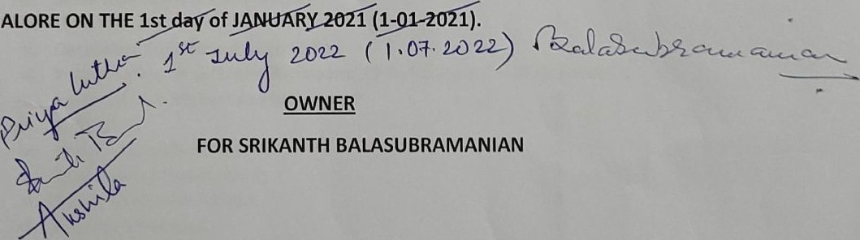

BANGALORE

V.S.BALASUBRAMANIAN 

General Power of Attorney

## TENANTS

1. SHRUTI BANSAL 2. Akshita Maheshwari 3. Ms. Priya Luthra

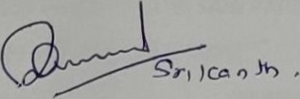WITNESSES:

1.)

2.)

## Annexure —l : List of accessories in the house. Flat 205 Aditya Elixir

The following accessories and fixtures are provided in working condition and should be returned in working condition at the time of vacating the house.

Sl. No. DescriDtionNos.

|  |  |
| --- | --- |
| Ceiling Fans : | 5 |
| ii. Tube light fittings with bulbs : | 8 |
| iii. Small tube lights in bath rooms | 3 |
| iv. Light Holders | 8 |
| v. Decorative Light fittings with bulbs | 4 |

vi. Water heaters in attached Bathroom: 25 litre capacity, Model: Racold: 3

|  |  |
| --- | --- |
| vii. Exhaust fan in kitchen and bathrooms: | 4 |
| viii. Calling bell • | 1 |
| Wardrobes with mirror | 1 |
| x. Wardrobes without mirror | 3 |
| xi. Curtain rods with holders | 8 |
| xii. Keys for front door | 2 |
| xiii. Keys for two bedrooms | 3(One each) |
| xiv. Wardrobe keys and Postbox key | 1 each |
| xv. Wash basin in the three toilets | 3 each |
| xvi. Mirrors | 3 |
| xvii. Health faucets xviii. Kitchen cabinets xix. Extra slab and sink in kitchen | 3 |
| xx. Towel Rods | 3 |
| xxi. Towel Rings | 3 |

xxii. Corner soap dish 3 xxiii. Doors, hinges, handles, bolt in hall, balconies & bedrooms xxiv. Door stoppers in all the doors xxv. Window locks xxvi. Wardrobes hinges, handles, doors, hanger rods

|  |  |
| --- | --- |
| xxvii. Water taps | 6 |
| xxviii. Wall Mixer | 3 |
| xxix, Showers | 3 |
| xxx. Toilet seat covers and bolts | 3 |
| xxxi. Flush Tanks | 3 |
| xxxii. IV Stand | 1 |

xxxiii. Pooja room with two shelves and one small almirah

IN WITNESS WHEREOF, THE SAID PARTIES TO THESE PRESENT HAVE HERE SIGNED AT BANGALORE ON THE

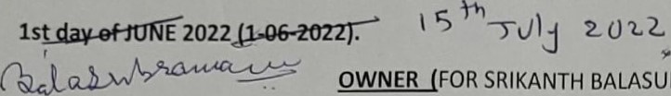BALASUBRAMANIAN)



V.S.BALASUBRAMANIAN (General Power of Attorney)

## TENANTS

1. SHRUTI BANSAL 2. Akshita Maheshwari 3. Ms. Priya Luthra

Details of OWNER's Bank account for Online Transfer of rent by TENANTS to OWNER:

|  |  |  |
| --- | --- | --- |
| Name of account holder | | SRIKANTH BALASUBRAMANIAN |
| Name of Bank | | IDBI Bank |
| Branch | | Aswini Complex, #326, 6t Main  Indirana ar, 2nd sta e, Ban alore |
| Account Number | | 020 210 4000 2494 16 |
| T | e of account | Savin s |
| Bank IFSC Code | | 1BKL0000202 |
| PAN Number | | AVEPB6161E |